2016 Season
Auction draft format.

RK = Rank at the end of the season
Team = Team Name (Team owner)
REC = Record at the end of the season
PF = Points For; number of points the team scored that year. How strong of a team they were offensively.
PA = Points Against; number of points scored against the team that year. How strong or weak their competition was that year.
PF/G = Points For per Game; average number of points scored per game by the team that year
PA/G = Points Against per Game; avg number of points scored against the team per game that year
DIFF = Average point differential that year. + means scored more than opponents, - means scored less than opponents.
MOVES = number of trades, waiver wire acquisitions, player drops or other roster moves.

Final Records & Stats

RK | Team | REC | PF | PA | PF/G | PA/G | DIFF | MOVES
1 | UNCLE RICO (Matt Lehman) | 9-4-0 | 1637.4 | 1472.1 | 126.0 | 113.2 | +12.7 | 45
2 | Tae Kwon Joe (Joe Rasar) | 9-4-0 | 1686.4 | 1508.3 | 129.7 | 116.0 | +13.7 | 19
3 | Sergeant Shultz (John Shultz) | 9-4-0 | 1671.1 | 1503.8 | 128.5 | 115.7 | +12.9 | 46
4 | Lucky Moe Fo (jason moe) | 8-5-0 | 1598.8 | 1564.8 | 123.0 | 120.4 | +2.6 | 43
5 | THE REAPER (rey salinas) | 8-5-0 | 1610.7 | 1495.7 | 123.9 | 115.1 | +8.8 | 65
6 | GARBAGE TIME (Wuellner Wuellner) | 8-5-0 | 1605.6 | 1564.8 | 123.5 | 120.4 | +3.1 | 15
7 | Best Friend DOUG (Bruce Lehman) | 6-7-0 | 1578.3 | 1637.4 | 121.4 | 126.0 | -4.5 | 31
8 | KWISATZ HADERACH (Kevin Roth) | 3-10-0 | 1507.9 | 1658.6 | 116.0 | 127.6 | -11.6 | 16
9 | Kenny powers Bitches (nick crandall) | 3-10-0 | 1560.4 | 1715.6 | 120.0 | 132.0 | -11.9 | 22
10 | I got a Thielen (Garrett Hanstead) | 3-10-0 | 1476.2 | 1749.8 | 113.6 | 134.6 | -21.0 | 66
11 | my jimmy in your mouth (Andy Cross) | 7-6-0 | 1605.3 | 1541.9 | 123.5 | 118.6 | +4.9 | 24
12 | The JOHNSON (Robbie Johnson) | 5-8-0 | 1437.6 | 1562.9 | 110.6 | 120.2 | -9.6 | 16

Final Week Scores

Winner's Bracket
- 
- UNCLE RICO
- (9-4-0, 1st in TRUMP Division)
- 131.9
- 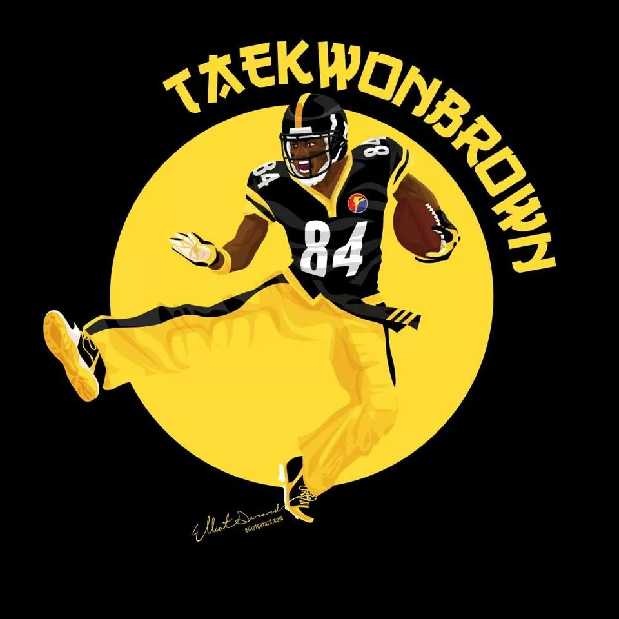
- Tae Kwon Joe
- (9-4-0, 1st in BERNIE Division)
- 114.7
CHAMPIONSHIP MATCHUP

Winner's Consolation Ladder
- Lucky Moe Fo
- (8-5-0, 2nd in HILLARY Division)
- 83.2
- 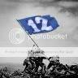
- Sergeant Shultz
- (9-4-0, 2nd in TRUMP Division)
- 120.4
- 
- THE REAPER
- (8-5-0, 1st in HILLARY Division)
- 145.1
- 
- GARBAGE TIME
- (8-5-0, 1st in OBAMA Division)
- 75.2

Consolation Ladder
- KWISATZ HADERACH
- (3-10-0, 3rd in HILLARY Division)
- 69.5
- 
- Best Friend DOUG
- (6-7-0, 3rd in TRUMP Division)
- 181.5
- I got a Thielen
- (3-10-0, 3rd in BERNIE Division)
- 111.4
- Kenny powers Bitches
- (3-10-0, 2nd in BERNIE Division)
- 198.4
- 
- The JOHNSON
- (5-8-0, 3rd in OBAMA Division)
- 120.1
- 
- my jimmy in your mouth
- (7-6-0, 2nd in OBAMA Division)
- 140.4

Draft Results: The draft results spreadsheet has been lost so for 2016 we have the players drafted by each team but not the auction values.

Tae Kwon Joe
NO. | Player | ROUND
7 | Philip Rivers SD, QB | 1
18 | Melvin Gordon SD, RB | 2
31 | Carlos Hyde SF, RB | 3
42 | Antonio Brown Pit, WR | 4
55 | Mike Evans TB, WR | 5
66 | Kelvin Benjamin Car, WR | 6
79 | Jordan Cameron Mia, TE | 7
90 | Eagles D/ST Phi, D/ST | 8
103 | Brandon McManus Den, K | 9
114 | Jordan Matthews Phi, WR | 10
127 | Demaryius Thomas Den, WR | 11
138 | Torrey Smith Phi, WR | 12
151 | Charles Sims TB, RB | 13
162 | Matthew Stafford Det, QB | 14
Kenny powers Bitches
NO. | Player | ROUND
2 | Ben Roethlisberger Pit, QB | 1
23 | David Johnson Ari, RB | 2
26 | Arian Foster Mia, RB | 3
47 | Sammy Watkins Buf, WR | 4
50 | DeVante Parker Mia, WR | 5
71 | Chris Ivory Jax, RB | 6
74 | Rob Gronkowski NE, TE | 7
95 | Panthers D/ST Car, D/ST | 8
98 | Dan Bailey Dal, K | 9
119 | Danny Woodhead Bal, RB | 10
122 | Travis Benjamin SD, WR | 11
143 | Michael Floyd NE, WR | 12
146 | Tavon Austin LA, WR | 13
167 | Kevin White Chi, WR | 14
Lucky Moe Fo
NO. | Player | ROUND
8 | Tom Brady NE, QB | 1
17 | Jamaal Charles KC, RB | 2
32 | DeMarco Murray Ten, RB | 3
41 | Allen Robinson Jax, WR | 4
56 | Brandin Cooks NE, WR | 5
65 | Corey Coleman Cle, WR | 6
80 | Julius Thomas Mia, TE | 7
89 | Vikings D/ST Min, D/ST | 8
104 | Blair Walsh Sea, K | 9
113 | Ameer Abdullah Det, RB | 10
128 | Isaiah Crowell Cle, RB | 11
137 | Vincent Jackson TB, WR | 12
152 | Tyrod Taylor Buf, QB | 13
161 | Dwayne Allen NE, TE | 14
UNCLE RICO
NO. | Player | ROUND
12 | Derek Carr Oak, QB | 1
13 | Devonta Freeman Atl, RB | 2
36 | LeSean McCoy Buf, RB | 3
37 | Jeremy Maclin KC, WR | 4
60 | Jarvis Landry Mia, WR | 5
61 | C.J. Anderson Den, RB | 6
84 | Delanie Walker Ten, TE | 7
85 | Texans D/ST Hou, D/ST | 8
108 | Stephen Gostkowski NE, K | 9
109 | Marvin Jones Det, WR | 10
132 | Gary Barnidge Cle, TE | 11
133 | Darren Sproles Phi, RB | 12
156 | Rashad Jennings NYG, RB | 13
157 | Eli Manning NYG, QB | 14
THE REAPER
NO. | Player | ROUND
3 | Aaron Rodgers GB, QB | 1
22 | Adrian Peterson Min, RB | 2
27 | Ezekiel Elliott Dal, RB | 3
46 | Alshon Jeffery Phi, WR | 4
51 | Golden Tate Det, WR | 5
70 | LeGarrette Blount NE, RB | 6
75 | Zach Miller Chi, TE | 7
94 | Seahawks D/ST Sea, D/ST | 8
99 | Roberto Aguayo TB, K | 9
118 | Jerick McKinnon Min, RB | 10
123 | Sammie Coates Pit, WR | 11
142 | Jaelen Strong Hou, WR | 12
147 | Jay Ajayi Mia, RB | 13
166 | Rishard Matthews Ten, WR | 14
The JOHNSON
NO. | Player | ROUND
6 | Andrew Luck Ind, QB | 1
19 | Lamar Miller Hou, RB | 2
30 | Eddie Lacy Sea, RB | 3
43 | Amari Cooper Oak, WR | 4
54 | Eric Decker NYJ, WR | 5
67 | Allen Hurns Jax, WR | 6
78 | Zach Ertz Phi, TE | 7
91 | Bengals D/ST Cin, D/ST | 8
102 | Justin Tucker Bal, K | 9
115 | Jonathan Stewart Car, RB | 10
126 | Duke Johnson Jr. Cle, RB | 11
139 | Josh Gordon Cle, WR | 12
150 | Stefon Diggs Min, WR | 13
163 | Devin Funchess Car, WR | 14
Sergeant Shultz
NO. | Player | ROUND
11 | Kirk Cousins Wsh, QB | 1
14 | Le'Veon Bell Pit, RB | 2
35 | Justin Forsett Den, RB | 3
38 | Keenan Allen SD, WR | 4
59 | Brandon Marshall NYG, WR | 5
62 | Bruce Ellington SF, WR | 6
83 | Jordan Reed Wsh, TE | 7
86 | Broncos D/ST Den, D/ST | 8
107 | Graham Gano Car, K | 9
110 | DeAngelo Williams Pit, RB | 10
131 | Antonio Gates SD, TE | 11
134 | Kamar Aiken Ind, WR | 12
155 | Terrance West Bal, RB | 13
158 | Shane Vereen NYG, RB | 14
Best Friend DOUG
NO. | Player | ROUND
10 | Russell Wilson Sea, QB | 1
15 | Doug Martin TB, RB | 2
34 | Frank Gore Ind, RB | 3
39 | A.J. Green Cin, WR | 4
58 | Jordy Nelson GB, WR | 5
63 | Doug Baldwin Sea, WR | 6
82 | Travis Kelce KC, TE | 7
87 | Raiders D/ST Oak, D/ST | 8
106 | Mason Crosby GB, K | 9
111 | Steve Smith Sr. Bal, WR | 10
130 | Derrick Henry Ten, RB | 11
135 | Theo Riddick Det, RB | 12
154 | Kyle Rudolph Min, TE | 13
159 | Matt Jones Wsh, RB | 14
I got a Thielen
NO. | Player | ROUND
5 | Marcus Mariota Ten, QB | 1
20 | Jeremy Langford Chi, RB | 2
29 | Matt Forte NYJ, RB | 3
44 | Dez Bryant Dal, WR | 4
53 | DeAndre Hopkins Hou, WR | 5
68 | Emmanuel Sanders Den, WR | 6
77 | Jason Witten Dal, TE | 7
92 | Patriots D/ST NE, D/ST | 8
101 | Adam Vinatieri Ind, K | 9
116 | Randall Cobb GB, WR | 10
125 | Giovani Bernard Cin, RB | 11
140 | Eric Ebron Det, TE | 12
149 | T.J. Yeldon Jax, RB | 13
164 | Robert Griffin III Cle, QB | 14
my jimmy in your mouth
NO. | Player | ROUND
1 | Carson Palmer Ari, QB | 1
24 | Thomas Rawls Sea, RB | 2
25 | Mark Ingram NO, RB | 3
48 | Julio Jones Atl, WR | 4
49 | T.Y. Hilton Ind, WR | 5
72 | Michael Crabtree Oak, WR | 6
73 | Jimmy Graham Sea, TE | 7
96 | Chiefs D/ST KC, D/ST | 8
97 | Chris Boswell Pit, K | 9
120 | Tyler Eifert Cin, TE | 10
121 | Matt Ryan Atl, QB | 11
144 | Christine Michael GB, RB | 12
145 | Terrance Williams Dal, WR | 13
168 | Jimmy Garoppolo NE, QB | 14
KWISATZ HADERACH
NO. | Player | ROUND
4 | Jeremy Hill Cin, RB | 1
21 | Todd Gurley LA, RB | 2
28 | Sterling Shepard NYG, WR | 3
45 | John Brown Ari, WR | 4
52 | Tyler Lockett Sea, WR | 5
69 | Greg Olsen Car, TE | 6
76 | Rams D/ST LA, D/ST | 7
93 | Chandler Catanzaro NYJ, K | 8
100 | DeSean Jackson TB, WR | 9
117 | Martellus Bennett GB, TE | 10
124 | Ryan Mathews Phi, RB | 11
141 | Bilal Powell NYJ, RB | 12
148 | Austin Seferian-Jenkins NYJ, TE | 13
165 | Cam Newton Car, QB | 14
GARBAGE TIME
NO. | Player | ROUND
9 | Drew Brees NO, QB | 1
16 | Dion Lewis NE, RB | 2
33 | Latavius Murray Min, RB | 3
40 | Odell Beckham Jr. NYG, WR | 4
57 | Julian Edelman NE, WR | 5
64 | Larry Fitzgerald Ari, WR | 6
81 | Coby Fleener NO, TE | 7
88 | Cardinals D/ST Ari, D/ST | 8
105 | Steven Hauschka Buf, K | 9
112 | Donte Moncrief Ind, WR | 10
129 | Blake Bortles Jax, QB | 11
136 | Willie Snead NO, WR | 12
153 | Jameis Winston TB, QB | 13
160 | Markus Wheaton Chi, WR | 14

UNCLE RICO (Matt Lehman)

STARTERS |  | Offseason |  |  | 2016 season
SLOT | Player | %ST | %ROST | +/- | PRK | FPTS | avg | LAST
QB |   Matt Ryan  AtlQB | 82.4 | 97.5 | +0.2 | -- | 372.1 | 23.3 | --
RB | 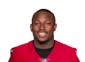  LeSean McCoy  BufRB | 98.2 | 99.8 | 0 | -- | 315.3 | 21.0 | --
RB |   Bilal Powell  NYJRB | 69.1 | 89.5 | +1.1 | -- | 201.0 | 12.6 | --
WR |   Mike Evans  TBWR | 98.9 | 99.9 | 0 | -- | 313.1 | 19.6 | --
WR |   Alshon Jeffery  PhiWR | 56.3 | 86.5 | +0.8 | -- | 148.1 | 12.3 | --
TE |   Zach Ertz  PhiTE | 63.9 | 82.1 | +1.6 | -- | 187.6 | 13.4 | --
FLEX |   Jarvis Landry  MiaWR | 44.4 | 93.2 | +0.1 | -- | 246.3 | 15.4 | --
D/ST |   Chiefs  KCD/ST | 72.9 | 90.9 | +0.5 | -- | 248.0 | 15.5 | --
K |   Stephen Gostkowski  NEK | 79.8 | 93.5 | +0.2 | -- | 132.0 | 8.3 | --
 |  |  |  | TOTALS |  | 2163.5 | 141.29 | 0.0
Bench | 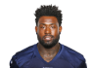  Delanie Walker  TenTE | 68.7 | 97.5 | 0 | -- | 190.1 | 12.7 | --
Bench | 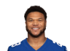  Devontae Booker  DenRB | 23.4 | 70.7 | 0 | -- | 143.7 | 9.0 | --
Bench | 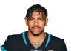  Terrelle Pryor Sr.  WshWR | 24.0 | 83.4 | +0.2 | -- | 219.4 | 13.7 | --
Bench | 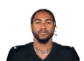  DeSean Jackson  TBWR | 65.9 | 85.0 | +1.1 | -- | 197.5 | 13.2 | --
Bench |   Tyler Lockett  SeaWR | 0.6 | 21.4 | -4.1 | -- | 155.1 | 10.3 | --
 |  |  |  | TOTALS |  | 905.8 | 58.87 | 0.0
IR |   Empty | -- | -- | -- | -- | -- | -- | --

Tae Kwon Joe (Joe Rasar)

STARTERS |  | Offseason |  |  | 2016 season
SLOT | Player | %ST | %ROST | +/- | PRK | FPTS | avg | LAST
QB |   Philip Rivers  SDQB | 35.4 | 83.9 | +0.1 | -- | 282.9 | 17.7 | --
RB | 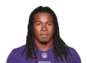  Devonta Freeman  AtlRB | 98.6 | 99.9 | 0 | -- | 291.1 | 18.2 | --
RB |   Jordan Howard  ChiRB | 92.2 | 96.3 | +0.2 | -- | 244.1 | 16.3 | --
WR |   Antonio Brown  PitWR | 10.5 | 99.3 | -0.3 | -- | 318.3 | 21.2 | --
WR |   Demaryius Thomas  DenWR | 69.8 | 98.1 | -0.1 | -- | 233.3 | 14.6 | --
TE |   Greg Olsen  CarTE | 85.2 | 99.6 | -0.1 | -- | 214.3 | 13.4 | --
FLEX | 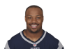  Jeremy Hill  CinRB | 15.0 | 95.2 | -0.3 | -- | 183.3 | 12.2 | --
D/ST |   Rams  LAD/ST | 17.1 | 37.3 | -3 | -- | 131.0 | 8.2 | --
K |   Caleb Sturgis  PhiK | 36.1 | 45.0 | +0.3 | -- | 143.0 | 8.9 | --
 |  |  |  | TOTALS |  | 2041.3 | 130.69 | 0.0
Bench | 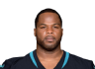  Carlos Hyde  SFRB | 4.0 | 79.7 | -4.3 | -- | 196.1 | 15.1 | --
Bench | 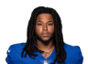  Kelvin Benjamin  CarWR | 36.9 | 91.2 | +0.4 | -- | 200.1 | 12.5 | --
Bench |   Rishard Matthews  TenWR | 17.5 | 66.1 | -0.5 | -- | 217.5 | 13.6 | --
Bench |   Marcus Mariota  TenQB | 1.7 | 56.3 | -5 | -- | 261.7 | 17.4 | --
Bench |   Rex Burkhead  NERB | 9.9 | 16.5 | +10.5 | -- | 79.9 | 5.7 | --
 |  |  |  | TOTALS |  | 955.3 | 64.34 | 0.0
IR |   Empty | -- | -- | -- | -- | -- | -- | --

Sergeant Shultz (John Shultz)

STARTERS |  | Offseason |  |  | 2016 season
SLOT | Player | %ST | %ROST | +/- | PRK | FPTS | avg | LAST
QB | 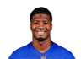  Jameis Winston  TBQB | 44.3 | 77.0 | +0.8 | -- | 265.9 | 16.6 | --
RB |   Le'Veon Bell  PitRB | 10.4 | 98.9 | -0.4 | -- | 331.4 | 27.6 | --
RB | 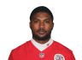  Spencer Ware  KCRB | 24.6 | 96.0 | -0.3 | -- | 198.8 | 14.2 | --
WR | 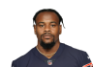  Ted Ginn Jr.  CarWR | 6.3 | 17.8 | -0.8 | -- | 184.0 | 11.5 | --
WR |   Robby Anderson  NYJWR | 0.8 | 4.9 | -1.1 | -- | 116.9 | 8.4 | --
TE | 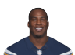  Antonio Gates  SDTE | 68.6 | 90.2 | +0.5 | -- | 147.8 | 11.4 | --
FLEX |   Michael Thomas  NOWR | 69.9 | 87.8 | +0.9 | -- | 261.7 | 17.4 | --
D/ST |   Titans  TenD/ST | 14.1 | 22.7 | +0.6 | -- | 111.0 | 6.9 | --
K |   Matt Bryant  AtlK | 89.5 | 92.0 | +0.5 | -- | 175.0 | 10.9 | --
 |  |  |  | TOTALS |  | 1792.5 | 124.98 | 0.0
Bench | 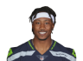  Brandon Marshall  NYGWR | 7.1 | 89.0 | +0.3 | -- | 159.8 | 10.7 | --
Bench | 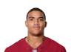  Jordan Reed  WshTE | 42.7 | 95.7 | +0.5 | -- | 168.6 | 14.1 | --
Bench |   DeAngelo Williams  PitRB | 57.6 | 75.4 | +11.8 | -- | 102.1 | 12.8 | --
Bench | 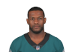  Mike Wallace  BalWR | 22.0 | 65.7 | -0.8 | -- | 212.8 | 13.3 | --
Bench | 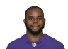  Kenneth Dixon  BalRB | 13.4 | 41.5 | -2 | -- | 102.4 | 8.5 | --
 |  |  |  | TOTALS |  | 745.7 | 59.3 | 0.0
IR |   Empty | -- | -- | -- | -- | -- | -- | --

Lucky Moe Fo (jason moe)

STARTERS |  | Offseason |  |  | 2016 season
SLOT | Player | %ST | %ROST | +/- | PRK | FPTS | avg | LAST
QB |   Tom Brady  NEQB | 75.3 | 99.4 | +0.1 | -- | 286.8 | 23.9 | --
RB | 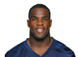  DeMarco Murray  TenRB | 94.2 | 99.4 | 0 | -- | 306.8 | 19.2 | --
RB |   Latavius Murray  MinRB | 69.7 | 96.6 | +0.1 | -- | 212.2 | 15.2 | --
WR |   Julian Edelman  NEWR | 85.8 | 97.7 | +0.1 | -- | 238.3 | 14.9 | --
WR |   Ty Montgomery  GBWR, RB | 77.3 | 89.9 | +1.7 | -- | 149.5 | 10.0 | --
TE |   Hunter Henry  SDTE | 10.4 | 30.8 | -1.6 | -- | 129.8 | 10.0 | --
FLEX |   Brandin Cooks  NEWR | 84.1 | 98.5 | 0 | -- | 262.3 | 17.5 | --
D/ST |   Packers  GBD/ST | 26.2 | 55.8 | -2.7 | -- | 129.0 | 8.1 | --
K |   Sebastian Janikowski  OakK | 45.1 | 56.1 | -1.4 | -- | 132.0 | 8.8 | --
 |  |  |  | TOTALS |  | 1846.7 | 127.43 | 0.0
Bench |   Allen Robinson  JaxWR | 65.4 | 94.4 | +0.4 | -- | 203.3 | 12.7 | --
Bench | 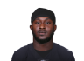  Isaiah Crowell  CleRB | 46.3 | 85.8 | -0.2 | -- | 216.1 | 13.5 | --
Bench |   Adrian Peterson  MinRB | 1.4 | 54.7 | -4.4 | -- | 9.0 | 3.0 | --
Bench | 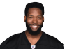  Ladarius Green  PitTE | 1.2 | 29.1 | -5.3 | -- | 56.4 | 9.4 | --
Bench | 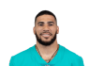  Kenneth Farrow  SDRB | 0.8 | 24.9 | -10 | -- | 37.2 | 3.4 | --
 |  |  |  | TOTALS |  | 522.0 | 41.99 | 0.0
IR |   Empty | -- | -- | -- | -- | -- | -- | --

THE REAPER (rey salinas)

STARTERS |  | Offseason |  |  | 2016 season
SLOT | Player | %ST | %ROST | +/- | PRK | FPTS | avg | LAST
QB |   Aaron Rodgers  GBQB | 95.8 | 99.9 | 0 | -- | 393.7 | 24.6 | --
RB |   Ezekiel Elliott  DalRB | 31.3 | 99.9 | 0 | -- | 348.4 | 23.2 | --
RB | 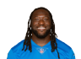  LeGarrette Blount  NERB | 87.8 | 97.9 | 0 | -- | 242.9 | 15.2 | --
WR |   Golden Tate  DetWR | 71.5 | 91.4 | +0.1 | -- | 232.1 | 14.5 | --
WR | 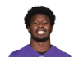  Sammy Watkins  BufWR | 37.2 | 78.6 | +1.3 | -- | 85.0 | 10.6 | --
TE |   C.J. Fiedorowicz  HouTE | 14.6 | 35.3 | -2.5 | -- | 133.9 | 8.9 | --
FLEX |   Dontrelle Inman  SDWR | 19.5 | 43.5 | 0 | -- | 173.0 | 10.8 | --
D/ST |   Seahawks  SeaD/ST | 90.0 | 98.1 | +0.1 | -- | 171.0 | 10.7 | --
K |   Adam Vinatieri  IndK | 83.2 | 92.6 | +0.1 | -- | 145.0 | 9.1 | --
 |  |  |  | TOTALS |  | 1925.0 | 127.63 | 0.0
Bench |   Tim Hightower  SFRB | 15.8 | 54.8 | -1.4 | -- | 132.8 | 8.3 | --
Bench | 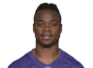  Jeremy Maclin  KCWR | 17.2 | 60.5 | +0.2 | -- | 109.5 | 9.1 | --
Bench |   Lions  DetD/ST | 5.9 | 21.6 | -1.4 | -- | 116.0 | 7.3 | --
Bench | 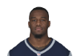  Mike Gillislee  BufRB | 6.4 | 25.4 | +0.2 | -- | 126.7 | 8.4 | --
Bench |   T.J. Yeldon  JaxRB | 1.3 | 37.8 | -3.4 | -- | 137.7 | 9.2 | --
 |  |  |  | TOTALS |  | 622.7 | 42.3 | 0.0
IR |   Empty | -- | -- | -- | -- | -- | -- | --

GARBAGE TIME (Wuellner Wuellner)

STARTERS |  | Offseason |  |  | 2016 season
SLOT | Player | %ST | %ROST | +/- | PRK | FPTS | avg | LAST
QB |   Drew Brees  NOQB | 86.5 | 99.4 | 0 | -- | 368.2 | 23.0 | --
RB |   Rashad Jennings  NYGRB | 15.3 | 73.8 | -1.8 | -- | 138.4 | 10.6 | --
RB | 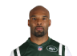  Matt Forte  NYJRB | 2.1 | 84.3 | -4.1 | -- | 187.6 | 13.4 | --
WR | 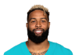  Odell Beckham Jr.  NYGWR | 69.2 | 99.9 | 0 | -- | 316.6 | 19.8 | --
WR | 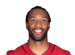  Larry Fitzgerald  AriWR | 68.4 | 97.9 | 0 | -- | 245.8 | 15.4 | --
TE |   Jermaine Gresham  AriTE | 4.3 | 9.7 | -0.5 | -- | 88.1 | 5.5 | --
FLEX |   Willie Snead  NOWR | 39.5 | 77.7 | +0.1 | -- | 196.5 | 13.1 | --
D/ST |   Giants  NYGD/ST | 23.5 | 55.8 | -2.2 | -- | 200.0 | 12.5 | --
K |   Steven Hauschka  BufK | 67.8 | 81.8 | +0.4 | -- | 128.0 | 8.0 | --
 |  |  |  | TOTALS |  | 1869.2 | 121.31 | 0.0
Bench |   Coby Fleener  NOTE | 28.0 | 57.1 | +0.7 | -- | 142.3 | 8.9 | --
Bench | 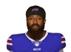  Jeremy Kerley  SFWR | 1.4 | 5.5 | -0.3 | -- | 150.7 | 9.4 | --
Bench |   Matt Asiata  MinRB | 8.9 | 29.4 | -0.3 | -- | 132.5 | 8.3 | --
Bench | 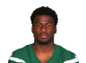  Quincy Enunwa  NYJWR | 4.8 | 28.4 | -0.3 | -- | 175.9 | 11.0 | --
Bench |   Cardinals  AriD/ST | 75.6 | 87.9 | +1.6 | -- | 187.0 | 11.7 | --
 |  |  |  | TOTALS |  | 788.4 | 49.28 | 0.0
IR |   Empty | -- | -- | -- | -- | -- | -- | --

Best Friend DOUG (Bruce Lehman)

STARTERS |  | Offseason |  |  | 2016 season
SLOT | Player | %ST | %ROST | +/- | PRK | FPTS | avg | LAST
QB |   Russell Wilson  SeaQB | 70.5 | 96.0 | +0.2 | -- | 279.7 | 17.5 | --
RB | 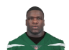  Frank Gore  IndRB | 87.4 | 96.5 | 0 | -- | 218.2 | 13.6 | --
RB |   Theo Riddick  DetRB | 1.0 | 67.8 | -6.7 | -- | 161.8 | 16.2 | --
WR |   Jordy Nelson  GBWR | 99.1 | 99.9 | 0 | -- | 314.7 | 19.7 | --
WR | 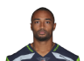  Doug Baldwin  SeaWR | 83.6 | 96.9 | 0 | -- | 260.6 | 16.3 | --
TE |   Travis Kelce  KCTE | 95.7 | 98.8 | +0.1 | -- | 238.0 | 14.9 | --
FLEX | 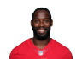  Pierre Garcon  SFWR | 25.5 | 46.3 | 0 | -- | 206.1 | 12.9 | --
D/ST |   Ravens  BalD/ST | 42.4 | 74.8 | -0.3 | -- | 174.0 | 10.9 | --
K |   Dan Bailey  DalK | 75.1 | 92.2 | +0.1 | -- | 135.0 | 8.4 | --
 |  |  |  | TOTALS |  | 1988.1 | 130.32 | 0.0
Bench | 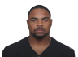  Doug Martin  TBRB | 3.2 | 71.8 | -9.9 | -- | 85.5 | 10.7 | --
Bench |   A.J. Green  CinWR | 2.5 | 85.5 | -2.8 | -- | 198.4 | 19.8 | --
Bench | 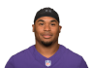  Steve Smith Sr.  BalWR | 45.6 | 71.4 | +0.4 | -- | 188.9 | 13.5 | --
Bench |   Darren Sproles  PhiRB | 58.0 | 78.6 | +0.7 | -- | 173.5 | 11.6 | --
Bench | 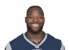  Martellus Bennett  GBTE | 42.0 | 84.3 | +1.7 | -- | 174.1 | 10.9 | --
 |  |  |  | TOTALS |  | 820.4 | 66.47 | 0.0
IR |   Empty | -- | -- | -- | -- | -- | -- | --

KWISATZ HADERACH (Kevin Roth)

STARTERS |  | Offseason |  |  | 2016 season
SLOT | Player | %ST | %ROST | +/- | PRK | FPTS | avg | LAST
QB |   Joe Flacco  BalQB | 10.1 | 27.0 | +0.2 | -- | 261.0 | 16.3 | --
RB |   Todd Gurley  LARB | 69.8 | 98.9 | 0 | -- | 198.2 | 12.4 | --
RB | 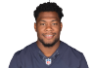  Jeremy Langford  ChiRB | 1.5 | 13.2 | +0.3 | -- | 73.2 | 6.1 | --
WR |   Jordan Matthews  PhiWR | 8.9 | 83.2 | +0.5 | -- | 173.4 | 12.4 | --
WR |   Davante Adams  GBWR | 73.7 | 91.2 | +0.8 | -- | 257.7 | 16.1 | --
TE |   Cameron Brate  TBTE | 5.9 | 48.1 | -8.1 | -- | 171.0 | 11.4 | --
FLEX | 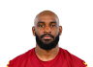  Jamison Crowder  WshWR | 28.3 | 76.0 | 0 | -- | 214.5 | 13.4 | --
D/ST |   Dolphins  MiaD/ST | 9.2 | 31.1 | -2.1 | -- | 174.0 | 10.9 | --
K |   Matt Prater  DetK | 66.1 | 76.9 | +0.4 | -- | 141.0 | 8.8 | --
 |  |  |  | TOTALS |  | 1664.0 | 107.79 | 0.0
Bench | 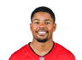  Sterling Shepard  NYGWR | 15.4 | 64.0 | +0.3 | -- | 186.4 | 11.6 | --
Bench | 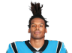  Cam Newton  CarQB | 42.1 | 97.1 | -0.1 | -- | 270.3 | 18.0 | --
Bench | 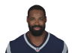  Kenny Britt  CleWR | 1.5 | 53.2 | -4.6 | -- | 200.2 | 13.3 | --
Bench |   Melvin Gordon  SDRB | 3.4 | 91.1 | -2.3 | -- | 256.6 | 19.7 | --
Bench | 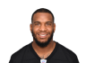  Eric Ebron  DetTE | 55.6 | 77.4 | +1.3 | -- | 144.2 | 11.1 | --
 |  |  |  | TOTALS |  | 1057.7 | 73.85 | 0.0
IR |   Empty | -- | -- | -- | -- | -- | -- | --

Kenny powers Bitches (nick crandall)

STARTERS |  | Offseason |  |  | 2016 season
SLOT | Player | %ST | %ROST | +/- | PRK | FPTS | avg | LAST
QB |   Kirk Cousins  WshQB | 55.6 | 87.4 | +0.9 | -- | 331.0 | 20.7 | --
RB |   David Johnson  AriRB | 98.8 | 100.0 | 0 | -- | 420.8 | 26.3 | --
RB |   Jay Ajayi  MiaRB | 67.8 | 97.3 | +0.1 | -- | 232.3 | 15.5 | --
WR |   Cameron Meredith  ChiWR | 31.7 | 51.0 | +4.7 | -- | 190.4 | 13.6 | --
WR | 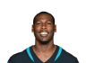  Marqise Lee  JaxWR | 7.1 | 14.1 | +1.7 | -- | 199.4 | 12.5 | --
TE | 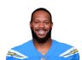  Lance Kendricks  GBTE | 1.7 | 5.5 | -0.4 | -- | 109.9 | 6.9 | --
FLEX |   DeVante Parker  MiaWR | 10.7 | 42.8 | -0.3 | -- | 161.4 | 10.8 | --
D/ST |   Eagles  PhiD/ST | 25.1 | 46.1 | +1.9 | -- | 204.0 | 12.8 | --
K |   Graham Gano  CarK | 25.8 | 39.5 | +0.4 | -- | 130.0 | 8.1 | --
 |  |  |  | TOTALS |  | 1979.2 | 127.04 | 0.0
Bench |   Ben Roethlisberger  PitQB | 6.8 | 93.6 | -0.4 | -- | 264.0 | 18.9 | --
Bench |   Rob Gronkowski  NETE | 2.0 | 40.4 | +1.9 | -- | 106.0 | 13.3 | --
Bench | 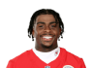  Jerick McKinnon  MinRB | 38.5 | 59.6 | +3.3 | -- | 148.4 | 9.9 | --
Bench |   Eli Rogers  PitWR | 5.6 | 14.0 | +2.7 | -- | 129.0 | 9.9 | --
Bench | 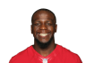  Mohamed Sanu  AtlWR | 17.1 | 40.1 | +0.7 | -- | 148.8 | 9.9 | --
 |  |  |  | TOTALS |  | 796.2 | 61.84 | 0.0
IR |   Empty | -- | -- | -- | -- | -- | -- | --

I got a Thielen (Garrett Hanstead)

STARTERS |  | Offseason |  |  | 2016 season
SLOT | Player | %ST | %ROST | +/- | PRK | FPTS | avg | LAST
QB |   Dak Prescott  DalQB | 9.2 | 85.9 | -0.1 | -- | 295.6 | 18.5 | --
RB | 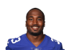  Dion Lewis  NERB | 16.8 | 45.6 | +0.7 | -- | 54.7 | 7.8 | --
RB | 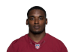  Robert Kelley  WshRB | 60.6 | 89.8 | +0.7 | -- | 134.6 | 9.6 | --
WR | 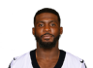  Dez Bryant  DalWR | 30.5 | 99.4 | 0 | -- | 189.0 | 14.5 | --
WR | 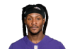  DeAndre Hopkins  HouWR | 54.6 | 96.6 | 0 | -- | 202.4 | 12.7 | --
TE |   Kyle Rudolph  MinTE | 67.7 | 87.2 | +0.7 | -- | 211.0 | 13.2 | --
FLEX |   Emmanuel Sanders  DenWR | 62.0 | 95.9 | 0 | -- | 219.6 | 14.6 | --
D/ST |   Chargers  SDD/ST | 17.1 | 45.0 | -5.1 | -- | 145.0 | 9.1 | --
K |   Wil Lutz  NOK | 21.0 | 25.3 | +1.8 | -- | 140.0 | 8.8 | --
 |  |  |  | TOTALS |  | 1591.9 | 108.73 | 0.0
Bench |   Derek Carr  OakQB | 2.4 | 69.9 | -3.6 | -- | 284.2 | 18.9 | --
Bench | 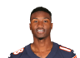  Taylor Gabriel  AtlWR | 1.1 | 49.6 | -7.2 | -- | 147.0 | 12.3 | --
Bench |   Vernon Davis  WshTE | 13.2 | 44.5 | -1.3 | -- | 114.3 | 7.6 | --
Bench |   Malcolm Mitchell  NEWR | 1.1 | 34.1 | -6.2 | -- | 99.1 | 8.3 | --
Bench | 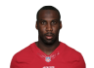  Anquan Boldin  DetWR | 10.7 | 27.8 | +0.1 | -- | 173.4 | 10.8 | --
 |  |  |  | TOTALS |  | 818.0 | 57.91 | 0.0
IR |   Ameer Abdullah  DetRB | 0.1 | 5.2 | +0.2 | -- | 26.8 | 13.4 | --

my jimmy in your mouth (Andy Cross)

STARTERS |  | Offseason |  |  | 2016 season
SLOT | Player | %ST | %ROST | +/- | PRK | FPTS | avg | LAST
QB | 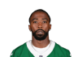  Tyrod Taylor  BufQB | 2.4 | 51.2 | -3.6 | -- | 281.4 | 18.8 | --
RB | 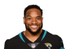  Thomas Rawls  SeaRB | 66.2 | 93.7 | +0.7 | -- | 78.5 | 8.7 | --
RB |   Mark Ingram  NORB | 83.8 | 97.7 | +0.1 | -- | 251.2 | 15.7 | --
WR |   T.Y. Hilton  IndWR | 96.3 | 99.4 | 0 | -- | 288.8 | 18.1 | --
WR | 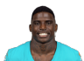  Tyreek Hill  KCWR | 59.8 | 79.4 | +1.9 | -- | 251.0 | 15.7 | --
TE |   Jimmy Graham  SeaTE | 78.8 | 97.0 | +0.2 | -- | 195.3 | 12.2 | --
FLEX | 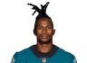  Julio Jones  AtlWR | 96.1 | 99.8 | 0 | -- | 278.9 | 19.9 | --
D/ST |   Bengals  CinD/ST | 22.2 | 48.1 | -1.6 | -- | 141.0 | 8.8 | --
K |   Dustin Hopkins  WshK | 63.4 | 70.5 | +1.4 | -- | 140.0 | 8.8 | --
 |  |  |  | TOTALS |  | 1906.1 | 126.61 | 0.0
Bench | 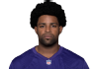  Michael Crabtree  OakWR | 36.3 | 94.1 | -0.1 | -- | 245.3 | 15.3 | --
Bench |   Tyler Eifert  CinTE | 4.0 | 66.1 | -4.2 | -- | 100.4 | 12.6 | --
Bench | 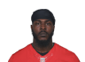  Tevin Coleman  AtlRB | 65.8 | 85.1 | +1.4 | -- | 196.1 | 15.1 | --
Bench |   Andy Dalton  CinQB | 18.1 | 55.7 | +0.4 | -- | 275.2 | 17.2 | --
Bench |   Tyrell Williams  SDWR | 57.4 | 85.4 | +0.4 | -- | 227.9 | 14.2 | --
 |  |  |  | TOTALS |  | 1044.9 | 74.41 | 0.0
IR |   Empty | -- | -- | -- | -- | -- | -- | --

The JOHNSON (Robbie Johnson)

STARTERS |  | Offseason |  |  | 2016 season
SLOT | Player | %ST | %ROST | +/- | PRK | FPTS | avg | LAST
QB |   Andrew Luck  IndQB | 69.5 | 99.2 | 0 | -- | 325.7 | 21.7 | --
RB | 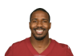  Lamar Miller  HouRB | 4.8 | 92.0 | -3.1 | -- | 199.1 | 14.2 | --
RB | 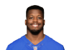  Jonathan Stewart  CarRB | 57.8 | 95.1 | +0.3 | -- | 148.4 | 11.4 | --
WR | 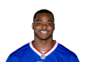  Amari Cooper  OakWR | 35.8 | 98.5 | -0.1 | -- | 243.3 | 15.2 | --
WR | 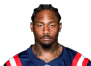  Stefon Diggs  MinWR | 3.2 | 84.5 | -2.1 | -- | 200.3 | 15.4 | --
TE |   Jason Witten  DalTE | 22.3 | 76.4 | -0.5 | -- | 154.3 | 10.3 | --
FLEX |   Dennis Pitta  BalTE | 35.1 | 52.6 | +1.9 | -- | 170.9 | 10.7 | --
D/ST |   Patriots  NED/ST | 75.4 | 92.0 | +0.2 | -- | 182.0 | 11.4 | --
K |   Justin Tucker  BalK | 89.4 | 95.3 | +0.2 | -- | 174.0 | 10.9 | --
 |  |  |  | TOTALS |  | 1798.0 | 121.18 | 0.0
Bench |   Allen Hurns  JaxWR | 0.2 | 30.5 | -0.1 | -- | 101.7 | 9.2 | --
Bench |   Ryan Mathews  PhiRB | 2.0 | 54.6 | -4.9 | -- | 148.6 | 11.4 | --
Bench | 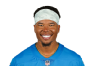  Marvin Jones  DetWR | 21.5 | 75.1 | -0.2 | -- | 181.3 | 12.1 | --
Bench |   Eli Manning  NYGQB | 15.3 | 66.3 | -0.5 | -- | 242.1 | 15.1 | --
Bench | 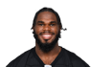  Wendell Smallwood  PhiRB | 0.1 | 7.0 | -0.5 | -- | 60.7 | 5.1 | --
 |  |  |  | TOTALS |  | 734.4 | 52.95 | 0.0
IR | 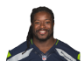  Eddie Lacy  SeaRB | 0.3 | 11.5 | +0.7 | -- | 44.8 | 9.0 | --

